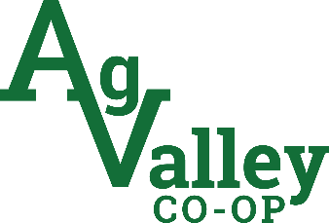

January 10th, 2024

Ag Valley Co-op is proud to offer scholarships to deserving high school seniors in our trade area.

The award amount of the Ag Valley Scholarship will remain the same at $500.00 payable for their second semester only. Visit our website, www.agvalley.com to learn more about our scholarship and to download applications for your students. You will find this under the “about us” tab on our home page. You can also contact Nikki Marquez for more information at 308-927-3681.

The deadline for application submission is April 5th, 2024. We encourage all students who plan on continuing their education to apply and wish the best to all upcoming graduates.

Return completed applications to:
Ag Valley Co-op
Attention: Nikki Marquez
P.O. Box 68
Edison, Ne 68936

